Dr. Reevesinator GoogleHappy Status Report

4/13/20

**TESTS**

Test 21: Calling users via name

Test 22: Test 21 but in different order to be certain it’s putting in the right order

Test 23: Test 21, different amount of strings

Test 24: Test 21, only calling 3 users

Test 25: Test 24, calling users in different positions on the teams.

**RELEASE WALL**

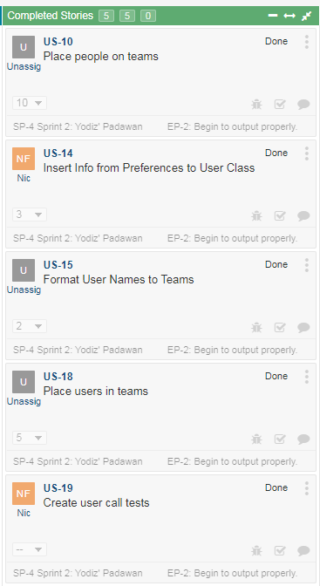

**STORYBOARD**

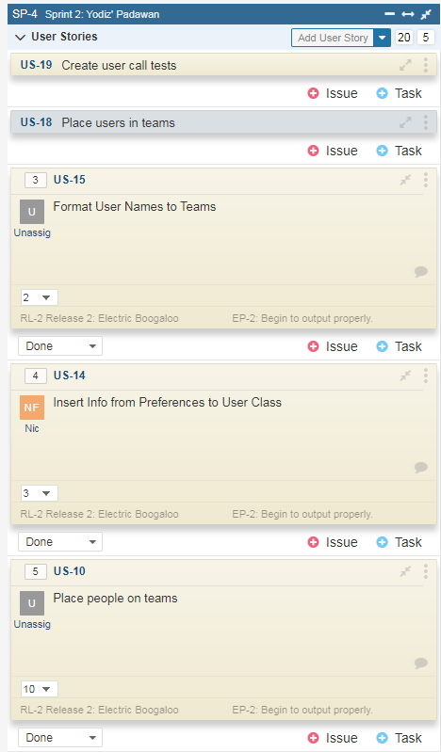

**CONTRIBUTION**

Ben: 45%

Nic: 40%

Wade: 15%

**UPDATED THINGS**

Tests were added, teams are now properly filled with a proper function and user info can be called, along with calling specific users.